Farewell to Bessie White
At the AGM on 18th July 2018 Bessie White stepped down after 12 years serving HFOF. She was Secretary for 9 years and then Communications Officer for the last 3 years. Her professionalism, energy and enthusiasm will be greatly missed. The many links of support and friendship she has made with faith and community groups in the Borough have raised the profile of HFOF and its aims of encouraging knowledge and mutual understanding between different religious faiths and promoting community harmony.
Charanjit AjitSingh, Chair of HFOF, thanked Bessie and presented her with a pendant and signed card as a token and record of gratitude from HFOF members.

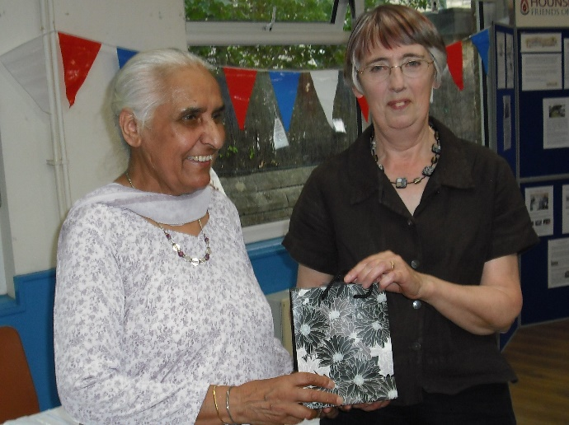

Lively Talk following AGM on 18th July
Clive Lawton OBE, a well-known Jewish educationalist, writer and broadcaster entertained and intrigued HFOF members with his talk entitled ‘Our differences are much more interesting than our similarities: Living Together in the 21st century’. The speaker shared his journey through life discovering and learning about different faiths. He began with his experience of growing up as part of a minority community in North London in the 50’s when differences in faith and culture were not subjects of interest to be shared and explored. In his view the world is made sparkling by diversity.

